**All good things come in threes: Triple-Shoot with the Cirrus-CC**

Professional crop production is faced with ever greater challenges. The withdrawal of individual plant protection agents along with increasing resistance as well as extreme climatic events such as severe drought, are just a few examples which have a significant impact on agriculture. This means that the demands on modern seeding systems are continuously growing. Precise seed metering and exact depth placement therefore have top priority when it comes to ensuring high yields and part-area, site-specific sowing and automatic switching on and off at the headland are also increasingly gaining in importance. Furthermore, there is a particular focus on the simultaneous application of several seed types or fertiliser as well as the addition of companion plants and undersown crops. This flexibility can be implemented to perfection with the new Cirrus-CC universal sowing combination.

**Sowing without limits**

The Cirrus-CC is equipped with a twin outlet, pressurised hopper and a second conveying system that feeds the supplementary FerTeC single-disc fertiliser coulters. If the new GreenDrill 501 universal catch crop seeder box is also used, up to three different materials can be applied simultaneously, and independently of each other, at different placement depths in the so-called triple-shoot process.

This seeding system provides the user with a variety of agronomical benefits. Companion plants and undersown crops are beneficial for weed suppression and erosion control as well as biodiversity and the Triple-shoot process enables the placement of three different seed types in one pass: Rape is sown in the upper horizon as a main cash crop e.g. via the TwinTeC+ double disc coulter. Field beans are placed deeper via the FerTeC single disc coulter and serve as a means of fixing nitrogen. Companion plants can be sown on the surface as a third medium via the GreenDrill seed baffle plates.

As an alternative, two seed types with fertiliser can also be applied at three different levels: In this case, a small quantity of fertiliser is placed directly by the grain via the sowing coulter in the single-shoot process. This greatly supports seedling development. Fertiliser is also placed in the deeper soil horizon between the seed rows via the FerTeC single-disc coulter by double-shoot, in order to stimulate root growth. This offset placement means that fertiliser can be used more precisely ensuring a more comprehensive supply to the plant. A companion plant is sown by the triple-shoot method via the GreenDrill. This gives the farmer or contractor great flexibility in combining seed and fertiliser.

**Easy handling**

The metering units in the twin outlet hopper and the GreenDrill can be calibrated very easily without constant climbing up and down by means of the optional TwinTerminal 3.0 fitted on the machine or via the mySeeder App. The application rates and speeds are clearly displayed on the Amazone AmaTron 4 ISOBUS terminal and the driver can change the seed rate from the tractor seat during work without any problems.

**Part-area, site-specific precision management**

When using application maps, all three hoppers can be individually controlled thanks to the MultiBin function and the application rates of the respective materials independently varied in part-area zones. The automatic GPS-Switch provides delayed switching at the headland for each material via the MultiBoom function.

**Further information and videos are available at:** [**www.triple-shoot.com**](http://www.triple-shoot.com)**/en**

 

Cirrus-CC Triple-Shoot animation Cirrus-6003-2CC with GreenDrill 501 in work

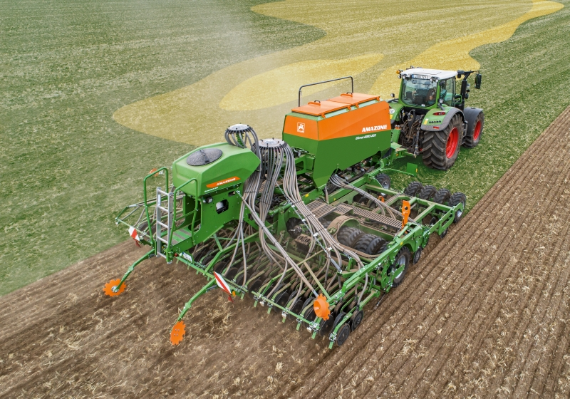

Water-conserving minimum-till sowing using the triple-shoot process via application maps.

*Picture: Cirrus6003-2CC\_Applikationskarte.jpg*

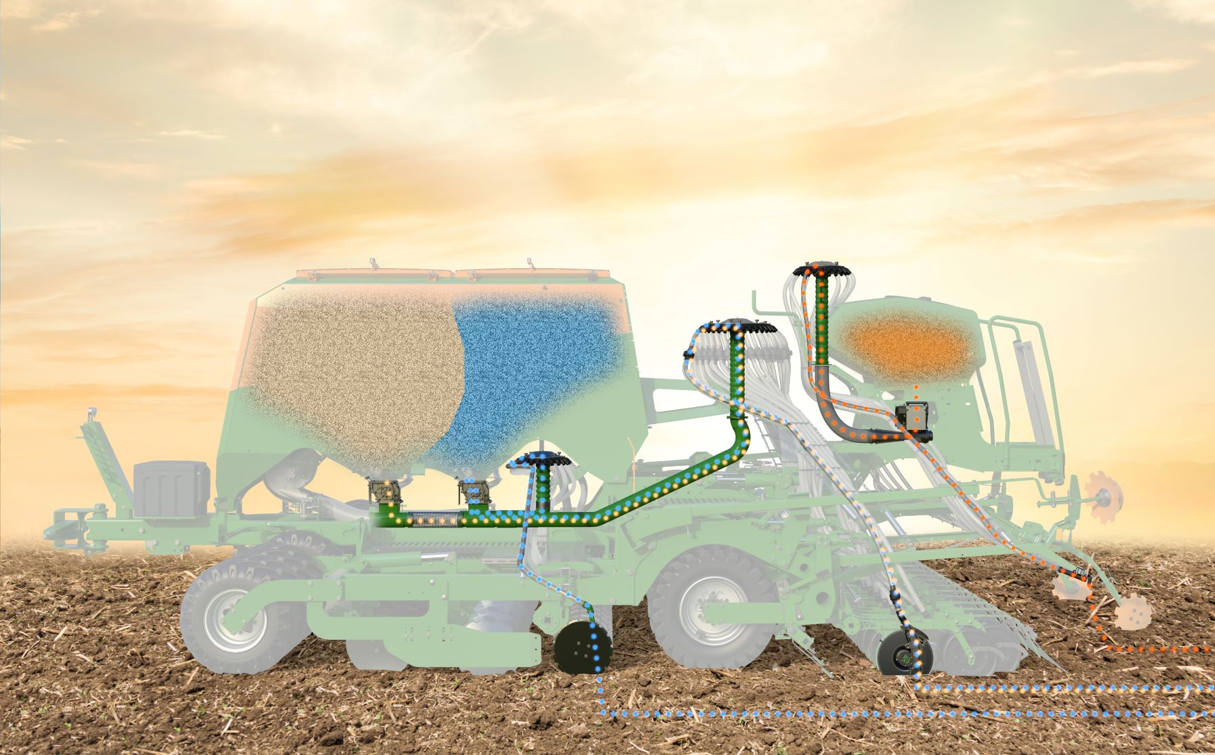

Cirrus-CC universal sowing combination with additional conveying system and GreenDrill 501 harrow-mounted seed drill for the application of up to three different materials.

*Picture: Saatfluss\_Triple Shoot\_Cirrus-CC\_GreenDrill.jpg*

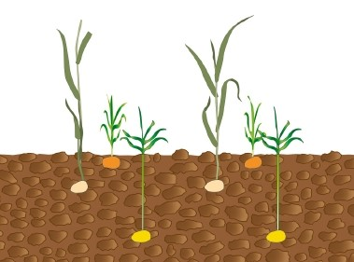

Triple-shoot: Sowing three different seed types at different placement depths

*Picture: Aussaatmethoden\_Cirrus-CC\_TripleShoot\_Saatgut.jpg*

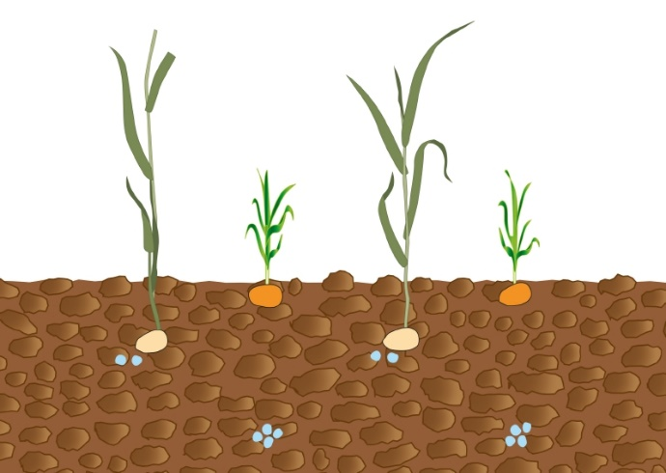

Triple-shoot: Sowing two seed types with fertiliser at three different placement depths

*Picture: Aussaatmethoden\_Cirrus-CC\_TripleShoot\_Saatgut\_Duenger.jpg*

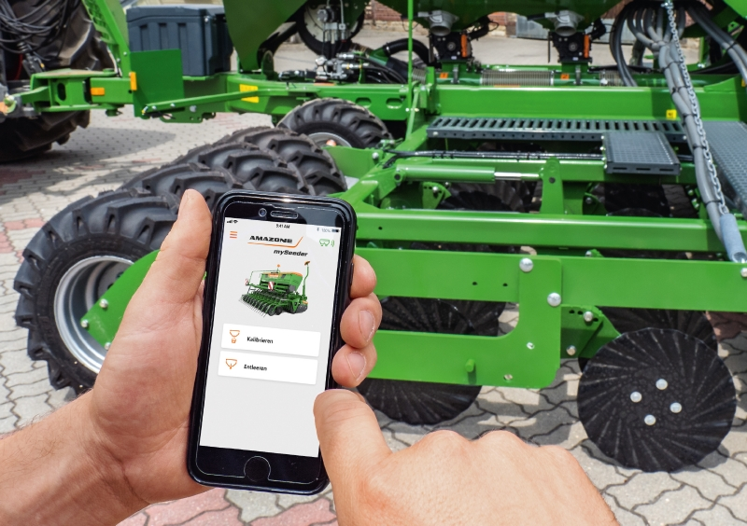

*Comfortable, precise calibration with the mySeeder app.*

*Picture: Cirrus6003-2CC\_Kalibrieren.jpg*

**About AMAZONE**

AMAZONEN-WERKE H. Dreyer GmbH & Co.KG, based in Hasbergen-Gaste in Germany, manufactures agricultural and groundcare machinery. The owner-managed company employs around 1900 people at nine different production sites in Germany, France, Russia and Hungary. The agricultural machinery range includes soil tillage implements, seed drills, fertiliser spreaders and plant protection equipment. Based on these core competencies, AMAZONE is now the specialist for intelligent crop production in agriculture.

Further information: [www.amazone.de](http://www.amazone.de) · Newsletter: www.amazone.de/newsletter

[cid:FB_70d43fd1-a841-4de4-bbaa-3e1f495f95d3.jpg](https://www.facebook.com/amazone.group) [cid:IG_efb650a7-31e4-4674-98db-f2d2d5c58dce.jpg](https://instagram.com/amazone_group) [cid:YT_e9180d16-5a2b-4618-92e9-22a015f9cafb.jpg](https://www.youtube.com/user/amazonede) [cid:LinkedIn_80de4e9c-c7a3-41e3-8e11-063f7eace13d.jpg](https://www.linkedin.com/company/amazone-group/) [cid:Xing1_e3730686-2953-47a9-9c47-dbaa518a9207.jpg](https://www.xing.com/company/amazone)