Cleverly combined with QuickLink
Amazone offers perfectly matched seed drill combinations for all soil conditions, farming systems and a multitude of farm sizes. Combining the various seed drills with different soil tillage implements and rollers is now extremely easy, fast and flexible thanks to the clever new QuickLink quick coupling system.

The QuickLink system is integrated into various Amazone seed drills and soil tillage implements, such as, for instance, the well-known AD conventional harrow-mounted seed drill, which can be combined with the KE rotary harrow or a KG or KX rotary cultivator. The quick coupling system is also available for the easy to use, and precise Cataya conventional seed drill as well as the flagship pneumatic seed drill, Centaya. In addition to an active soil tillage tool, the CombiDisc compact disc harrow is also available for the Cataya and Centaya. All combinations can be perfectly tailored to the respective field conditions by utilising the large selection of rollers.

Thanks to the QuickLink quick release coupling system, the soil tillage implement can be safely removed from the respective seed drill in just a few minutes without the need for tools. This is made possible by three easily accessible coupling points. As a result, the soil tillage system can then be used on its own for seedbed preparation. The seed drill can also be mounted on another QuickLink enabled soil tillage implement without any problems, meaning that several different seed drill combinations can now be implemented with one and the same harrow-mounted seed drill.
The use of QuickLink for single-seeder precision sowing technology provides extra added value. The KG and KX rotary cultivators used in cereal sowing can be combined quickly and easily with the Precea harrow-mounted precision seeder for maize sowing together with seedbed preparation in a single pass.
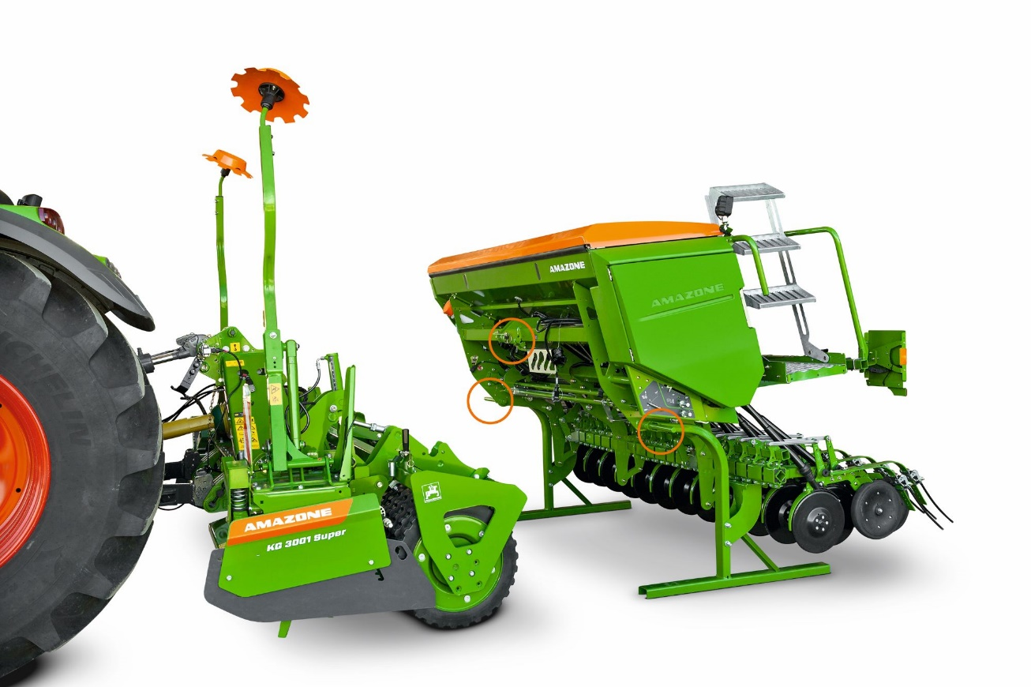
Picture: Amazone Cataya 3000 Super_KG 3001 Super_QuickLink.jpg
On or off – clever, simple and flexible with QuickLink!

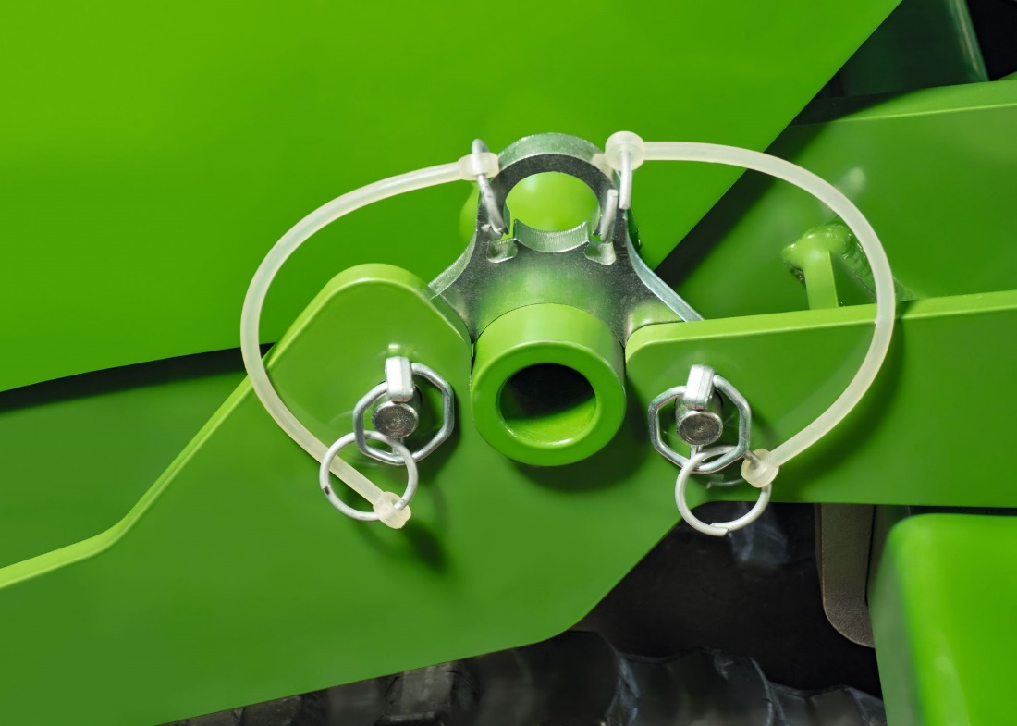
Picture: Amazone QuickLink_Detail.jpg
QuickLink quick coupling system

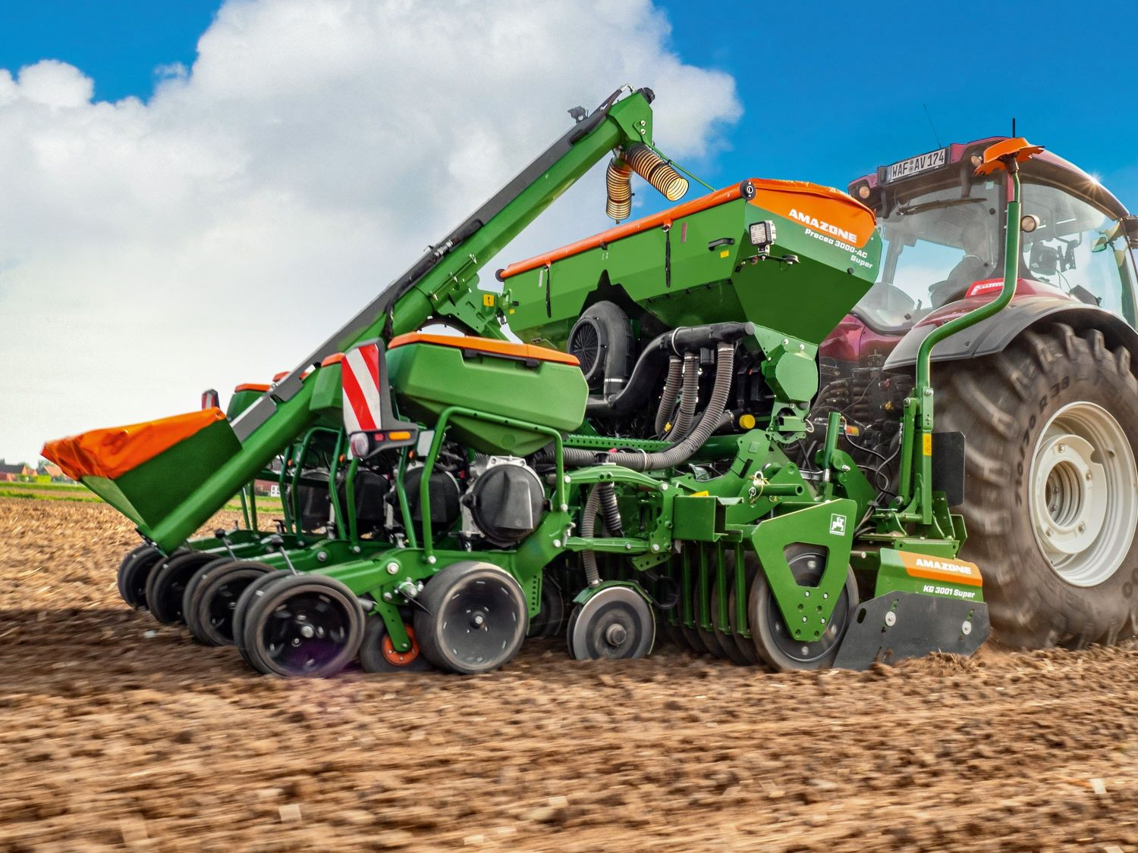
Picture: Amazone Precea 3000-AC Super_KG 3001 Super_QuickLink.jpg
The rotary cultivator can also be quickly and easily combined with the Precea harrow-mounted precision seeder via QuickLink.

